{{DATE}}

**{{CLIENT_NAME}}**

**{{ADDRESS}}**

**ATTENTION: {{CONTACT_PERSON}}**

Dear Sir/Madam,  
  
We take special pleasure in submitting our firm quotation for the KYOCERA DIGITAL COPIER ECOSYS M2540dn/L as follows:

**BLACK ‘n WHITE COPY & PRINT, COLORED SCAN**

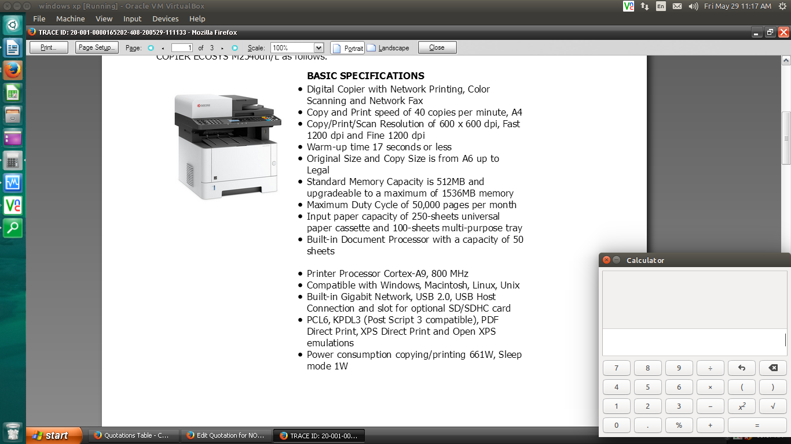

* **MACHINE PRICE (VAT INCLUSIVE)**

|  |  |  |
| --- | --- | --- |
| 1 unit of KYOCERA DIGITAL COPIER ECOSYS M2540dn/L | Php | 78,000.00 |

**PROMO**

MACHINE ORIGINAL PRICE: Php 78,000.00

LESS PROMO DISCOUNT Php 15,600.00

**TOTAL DISCOUNTED AMOUNT Php 62,400.00** **(Less 10% in COD => Php 56,160.00)**

Php 5,200.00/mo. for 12 months (Credit Card)

**ANNIVERSARY PROMO SPECIAL Php 44,776.80 (CASH)**

**(METRO MANILA ONLY)**

**UNTIL OCT. 25, 2025**

**OPTIONAL/ACCESSORIES (NOT INCLUDED IN THE MACHINE PRICE)**

STEEL TABLE/CABINET Php 6,700.00

3 YEARS SERVICE WARRANTY EXTENSION Php 6,600.00 (TOTAL 5 YEARS)

* **PRICE OF CONSUMABLES (PLUS VAT)**

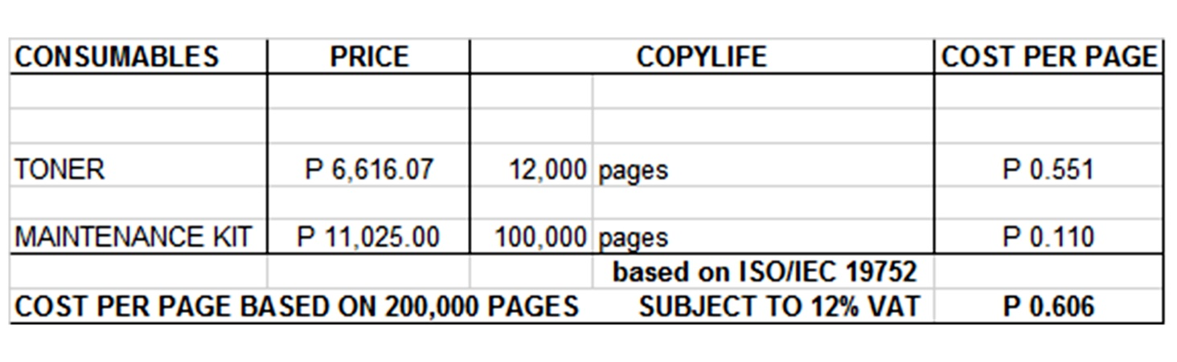

**Terms of Payment:** COD/12 months Credit Card

**VALIDITY:** Prices are subject to change without prior notice, please confirm with us prior to finalization of order.  
  
**WARRANTY:**   
  
KYOCERA DIGITAL PLAIN PAPER COPIERS are guaranteed spare parts replacement FREE OF CHARGE for ONE (1) year, or up to 100,000 copies/print/scan/fax whichever comes first.  
  
Warranty for accessories and options is ONE (1) year from the date of delivery.  
  
We also assure prompt service whenever you need assistance. Repair service is FREE for TWO (2) years.   
  
Installation and Training of Personnel: Our expert service engineers install all our machines and they will be glad to train interested personnel on the detailed mechanics of the machine free of charge.

Moreover, the amount quoted above excludes the cost of any required tests or medical certifications, such as, but not limited to, Rapid tests, Antigen tests, and RT-PCR tests. The actual cost will be billed separately.  
  
We are looking forward to hearing from you soon. For any questions or concerns, please feel free to call us at 7618-0274.  
  
  
Very truly yours, Conforme:

**JAYPEE V. SONIEL __________________________________**  
SENIOR ACCOUNT EXECUTIVE II

09176240820 (Viber Ready)